Project: Customer Order and Acquisition Analysis

"Customer Behaviour and Promotional Strategy Analysis Using SQL"

**Overview**

This project involves analysing an order table containing critical information about customer orders, including order details, customer behaviour, restaurant preferences, and promotional usage. The goal is to derive actionable insights by solving complex business questions related to customer acquisition, retention, and engagement.

**Dataset Structure**

The order table contains the following columns:

CREATE TABLE [dbo].[orders](

[Order_id] [varchar](20) NULL,

[Customer_code] [varchar](20) NULL,

[Placed_at] [datetime] NULL,

[Restaurant_id] [varchar](10) NULL,

[Cuisine] [varchar](20) NULL,

[Order_status] [varchar](20) NULL,

[Promo_code_Name] [varchar](20) NULL

) ON [PRIMARY]

GO

**Key Business Questions & Analysis**

* Top Restaurant by Cuisine Type

Identify the top-performing restaurant for each cuisine

* Daily New Customer Acquisition

Track the number of new customers acquired daily since the platform's launch.

* One-Time Customers in January 2025

Count users who placed their first order in January 2025, placed only one order that month, and did not order again.

* Inactive Customers (Acquired One Month Ago with No Recent Orders)

Retrieve a list of customers acquired one month ago (first order on promo) who have not placed any orders in the last 7 days.

* Trigger-Based Customer Engagement (Every 3rd Order)

Create a query to identify customers who have placed their 3rd, 6th, or 9th order for targeted communication.

* Promo-Exclusive Customers

List customers who placed more than one order, with all orders using a promo code.

* Customer Acquisition Percentage (January 2025, Non-Promo First Orders)

Calculate the percentage of customers acquired in January 2025 (first order without a promo code) out of the total customer base.

**Expected Outcomes**

* Insights into customer acquisition trends.
* Identification of high-value and churned customers.
* Optimization of promotional strategies.
* Data-driven decision-making for customer engagement campaigns.

**Technologies & Methods Used**

* SQL (Window functions, subqueries, aggregations, date filtering)
* Data Analysis (Customer segmentation, cohort analysis, retention metrics)
* Business Intelligence (Identifying growth opportunities, improving retention strategies)

1. Find top restaurant by cuisine type without using limit and top function.

select * from(

select *, ROW_NUMBER() over(partition by Cuisine order by TOTAL_ORDERS desc) as rn

from(

select Cuisine,restaurant_id, count(*) as TOTAL_ORDERS

from orders

group by Cuisine, restaurant_id

) A) B

where rn<2

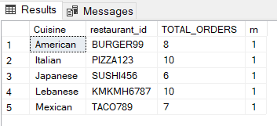

2. Find the daily new customer count from the launch date (everyday how many new customers are we acquiring)

select FIRST_ORDER_DATE, count(*) as NO_OF_NEW_CUSTOMERS

from(

select Customer_code, cast(min(Placed_at) as date) as FIRST_ORDER_DATE

from orders

group by Customer_code

) A

group by FIRST_ORDER_DATE

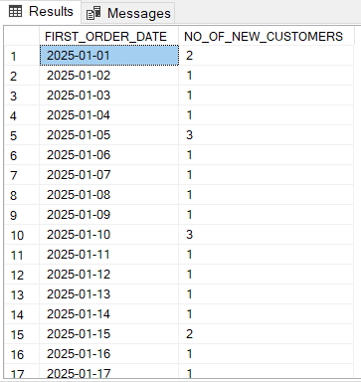

3. Count of all the users who were acquired in jan 2025 (1st order in jan) and only placed one order in jan and did not place any other order

select Customer_code

from orders

where DATEPART(MONTH,Placed_at)=1

and Customer_code not in (select Customer_code

from orders

where DATEPART(MONTH,Placed_at)>1

group by Customer_code)

group by Customer_code

having count(customer_code)=1

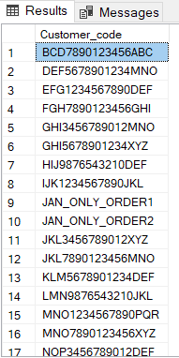

4. List of all the customers with no order in last 7 days but were acquired one month ago with their first order on promo.

--2025-03-31 to 2025-03-24

select *

from orders o1

inner join (

select Customer_code, MIN(Placed_at) as FIRST_ORDER_DATE

,MAX(Placed_at) as LATEST_ORDER_DATE

from orders

group by Customer_code) o2

on o1.Customer_code=o2.Customer_code and o1.Placed_at=o2.FIRST_ORDER_DATE

where o2.LATEST_ORDER_DATE< '2025-03-24' and

o2.FIRST_ORDER_DATE <'2025-02-28'and o1.Promo_code_Name is not null

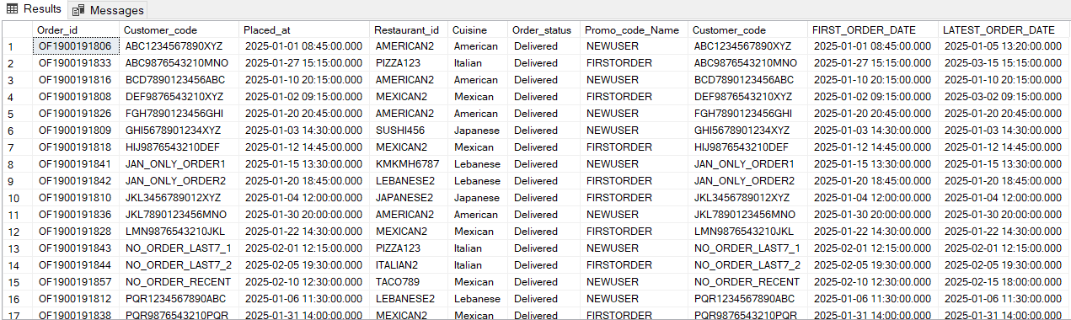

5. Growth team is planning to create a trigger that will target customers after their every third order with a personalized communication and they have asked you to create a query for this

(3rd, 6th, 9th)

select * from(

select *

,ROW_NUMBER() over(partition by customer_code order by placed_at) as ORDER_NUMBER

from orders)A

where ORDER_NUMBER%3=0 --and cast(Placed_at as date)=GETDATE()

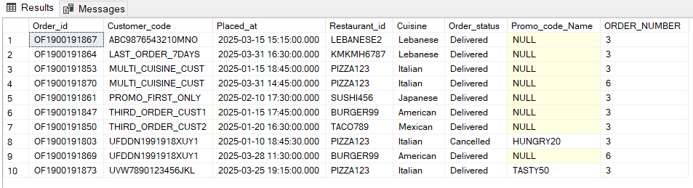

6. List customers who placed more than 1 order and all their orders on a promo only

select * from(

select Customer_code, count(*) as TOTAL_ORDERS, count(Promo_code_Name) as ORDERS_ON_PROMO

from orders

group by Customer_code) A

where TOTAL_ORDERS>1 and TOTAL_ORDERS=ORDERS_ON_PROMO

select Customer_code, count(*) as TOTAL_ORDERS, count(Promo_code_Name) as ORDERS_ON_PROMO

from orders

group by Customer_code

having count(*)>1 and count(*)=count(Promo_code_Name)

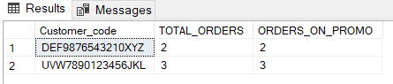

7. What %age of customers were originally acquired in jan 2025.(first order without promo code)

select count(case when rn=1 and Promo_code_Name is null then Customer_code end)*100/COUNT(distinct Customer_code) as PERC

from(

select *, ROW_NUMBER() over(partition by customer_code order by placed_at) as rn

from orders

where MONTH(Placed_at)=1) A

